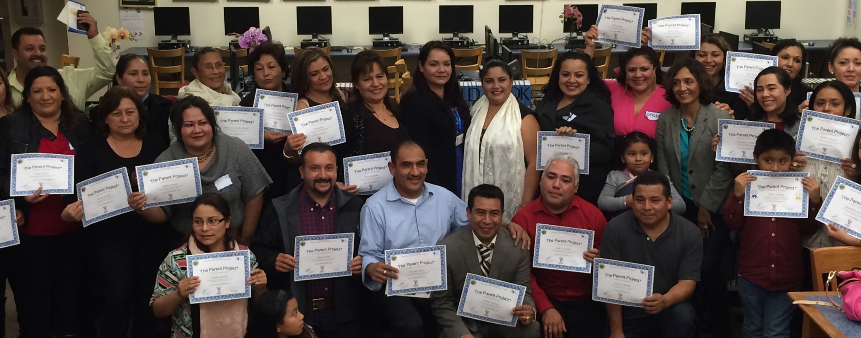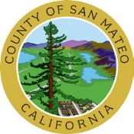

***Join the***

**ODE Parent Project®**

Find answers to your parenting questions

Do you want to build a stronger relationship with your kids?

The Parent Project® is a 12-week class that gives parents, grandparents, and caregivers the tools to build strong and healthy families. Contact the facilitator to register at least 3 weeks before class starts. ***All classes are free!***

|  |  |  |  |  |
| --- | --- | --- | --- | --- |
| **Start Date** | **Time** | **Language** | **Location** | **Contact/Registration** |
| Tuesday,  January 17th | 6pm-8:30pm | Spanish | Redwood City Library  1044 Middlefield Rd,  Redwood City, CA 94063 | María Diaz-Slocum  [Mdiaz-slocum@redwoodcity.org](mailto:Mdiaz-slocum@redwoodcity.org)  (650) 780-7037 |
| Thursday,  February 16th | 6pm-8:30pm | Spanish | Fiesta Gardens International School  1001 Bermuda Drive  San Mateo, CA 94403 | Eddy Caldera  parentproject@star-vista.org  (650) 554-0656 |
| Thursday,  February 16th | 6pm-8:30pm | English | Virtual Via Zoom | Brittany Afu  bafu@pcrcweb.org  650-513-0330 |
| Tuesday,  February 21st | 6pm-8:30pm | Spanish | Virtual Via Zoom | Lilia Quezada  parentproject@star-vista.org  (650) 465-6792 |

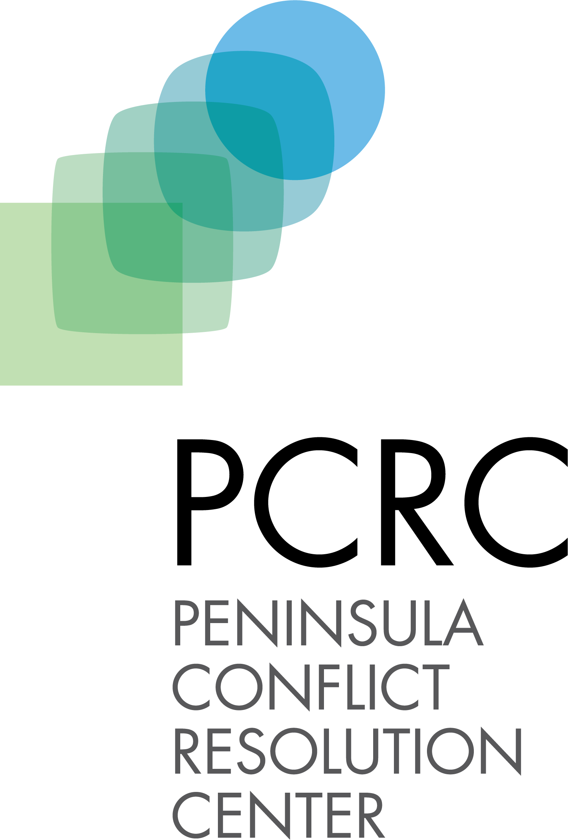

**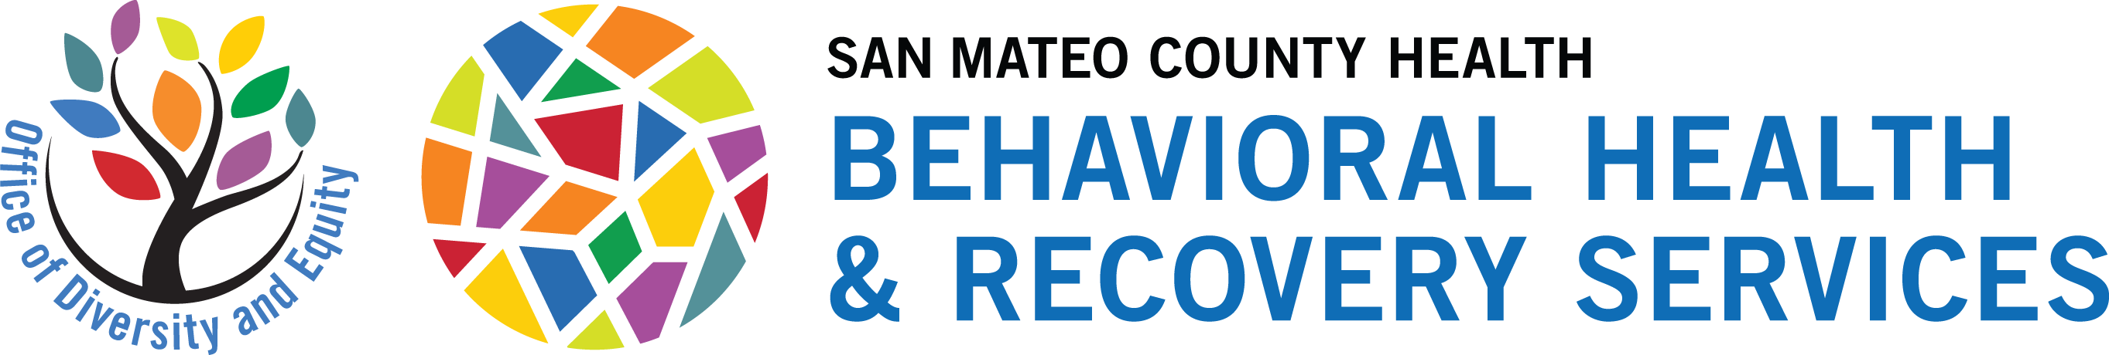****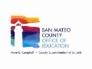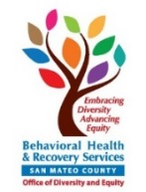[**www.smchealth.org/ParentProject**](http://www.smchealth.org/ParentProject)