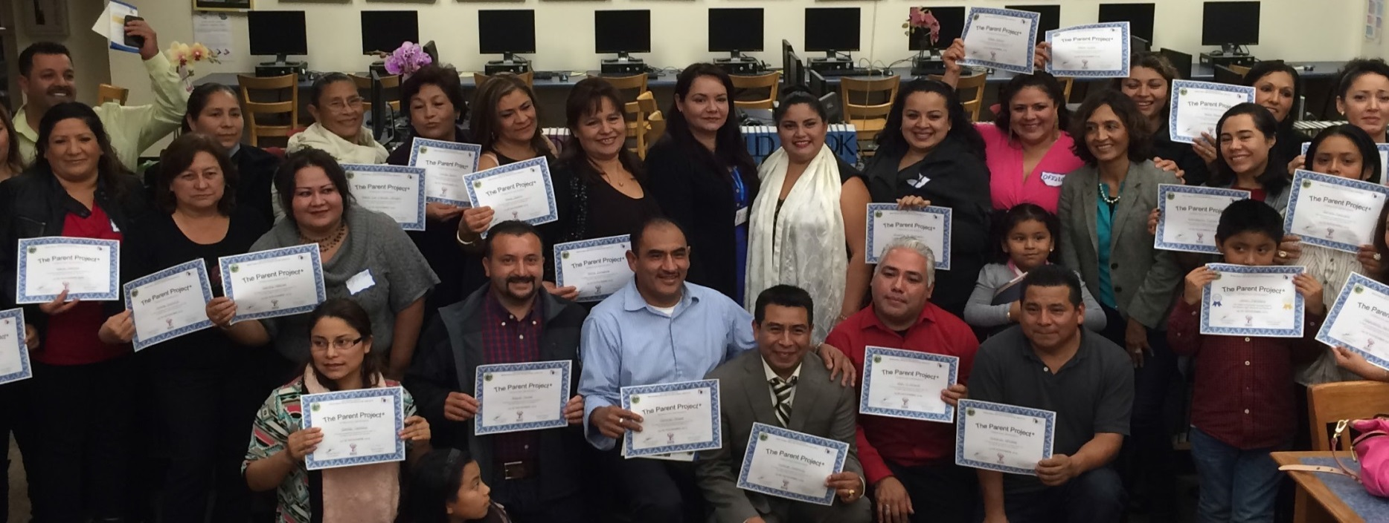

Join the
ODE Parent Project®

Find answers to your parenting questions

Do you want to build a stronger relationship with your kids?

The Parent Project® is a 12-week class that gives parents, grandparents, and caregivers the tools to build strong and healthy families.
All classes are free!

Sign up for the Parent Project® and get:

- Resources to help you and your kids

- Tools to increase your child’s success and attendance at school
- Tips to improve communication with your child

- Strategies to prevent their use of alcohol or drugs

- Practical tools that work for your family

Dinner and childcare provided! Childcare limited to first 20 children who sign up, ages 3-15, potty trained.

D AT E S

Classes start:

Thursday, February 16, 2023
6:00 pm – 8:30 pm

Fiesta Gardens International School
1001 Bermuda Drive
San Mateo CA 94403
Class dates:
2/16, 2/23, 3/2, 3/9, 3/16, 3/23, 4/6, 4/13, 4/20, 4/27, 5/4, 5/11

Class language:
Spanish

Register in advance:

Eddy Caldera
parentproject@star-vista.org
(650) 554-0656
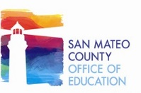

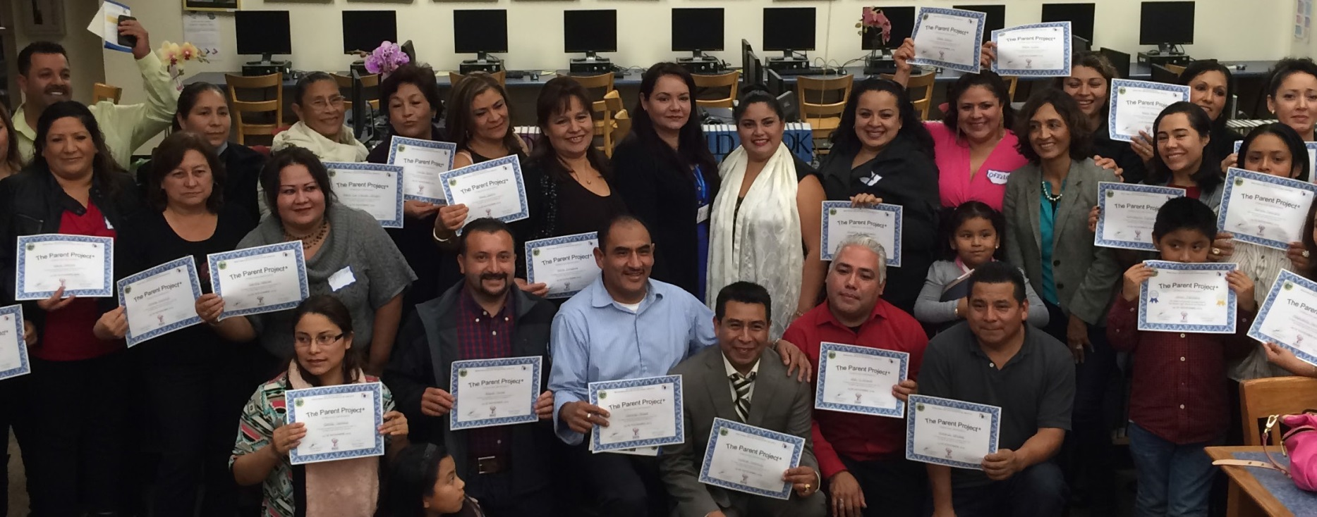

www.smchealth.org/ParentProject

